Redding Area Simplex Net.
Mondays 8:15 PM PM local time (except second Monday)
147.570 MHz FM

The purpose of the simplex net is to train and involve any interested radio amateur operator or those monitoring the simplex frequency to pass or relay information. You do not need to be a member of ARES (Amateur Radio Emergency Service) to participate, all radio amateurs and interested listeners are welcome to participate.

In the last few years many people in the Redding area passed their FCC technician license exams. Some people earned their ticket in the hopes that they could use their ham license in case of emergency or to monitor the ham bands during emergencies or disaster recovery. If you are one of these hams we really hope you will join us on the air for some simple message relay practice. Those of you who monitor the ham bands are also encourage to listen and copy down information as it is passed.

In each practice net, we provide a different Net Word of The Week. In a real world emergency situation, instead of the Net Word of The Week it could be an urgent public announcement or other information.

Those listening to the net are potential information relays to those around them who do not have access to ham radio or other receiver. This means you could be the vital link to information in an emergency.

Ham Radio Operators will be asked to check in after the Net Control Station gives a short preamble and announces the Net Word of the Week. Each Ham Radio Operator checking in will acknowledge the Net Word of the Week by repeating it when checking in and will also inform the Net Control Station which location zone he is located in. See Zone Map below.

Hams are asked to send in there "copy no copy" report to al@af6p.com
Listeners are asked to inform us if they heard the net and confirm that they heard the Net Word of the Week, email that information to al @af6p.com

Notes:
Please try to leave a pause in-between transmissions in order to hear breakers and relays.
Use enough power to acquire reliable communications.
Be prepared to “Relay” weak stations

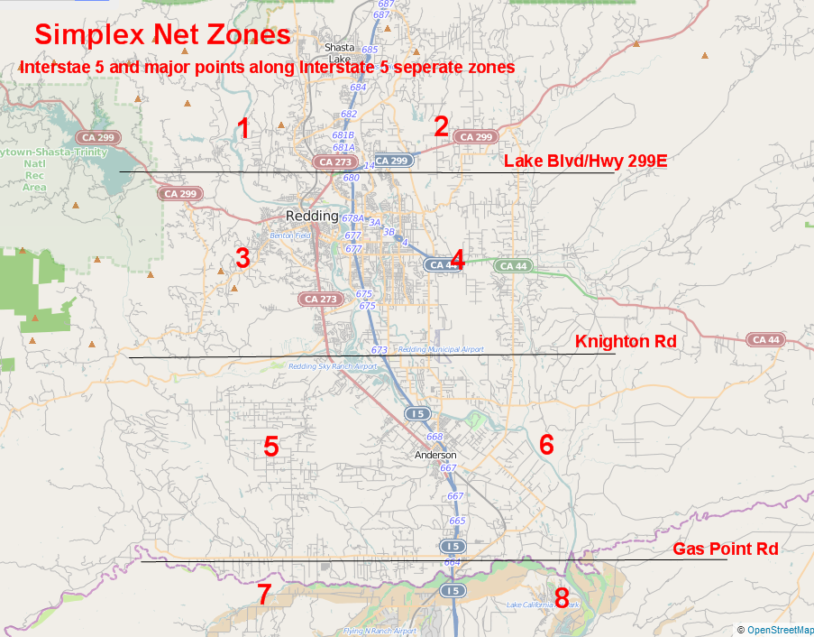

Because this is a simplex net, range may be limited to the Redding area and points with line of sight into the valley. There will be areas in which local terrain makes line of sight communications difficult or even impossible so please listen carefully.

